LAHD Foreclosure Registry Program

Properties in Foreclosure and in Bankruptcy - FAQ
If a property in foreclosure also has a current, active bankruptcy case for the debtor linked to the property with automatic stay protection for the creditor who has filed a notice of default, then the beneficiary, trustee or servicer of that loan in default may be exempt from registration and inspection requirements of the Ordinance. All bankruptcy cases are different, however, and each case must be submitted to and reviewed by the LAHD Foreclosure Registry Program in order to determine if the property requires registration or monthly inspection.

Beneficiaries, trustees, and/or servicers requesting exemption from the registration and inspection provisions of the ordinance in view of a bankruptcy petition must email their request to the LAHD, and in the process, provide a copy of the relevant bankruptcy docket for review and verification by the Foreclosure Registry Program (FRP).

Decisions/determinations on requests are contingent on the date that the request and all pertinent supporting documents are submitted to LAHD. Decisions are rendered based on document dates that might impact the foreclosure, the property’s beneficial ownership, penalties, etc. (i.e.: the date of filing, current status of the bankruptcy, granting of motions of relief from the automatic stay)

However, please note that if a property is already registered, providing bankruptcy case information will not qualify the property for de-registration, as bankruptcy does not end or cancel a foreclosure. Active, valid, bankruptcy cases, once approved by LAHD, only provide a temporary suspension in future registration and inspection requirements for as long as the bankruptcy remains active with stay protection for the creditor. Once bankruptcy protection is lifted, whether from case closure or a motion of relief being granted for the creditor, any property with an active Notice of Default must register immediately.

___________________________________________________________________________

HOW TO ACQUIRE A BANKRUPTCY DOCKET REPORT FOR FRP EXEMPTION REVIEW

Example Case Details:

BK Petition # 2:17-bk-XXXXX, filed by borrower Jane Doe on 12-15-2017

- Login to the PACER website:
US COURTS Electronic Records: https://pcl.uscourts.gov/pcl/index.jsf
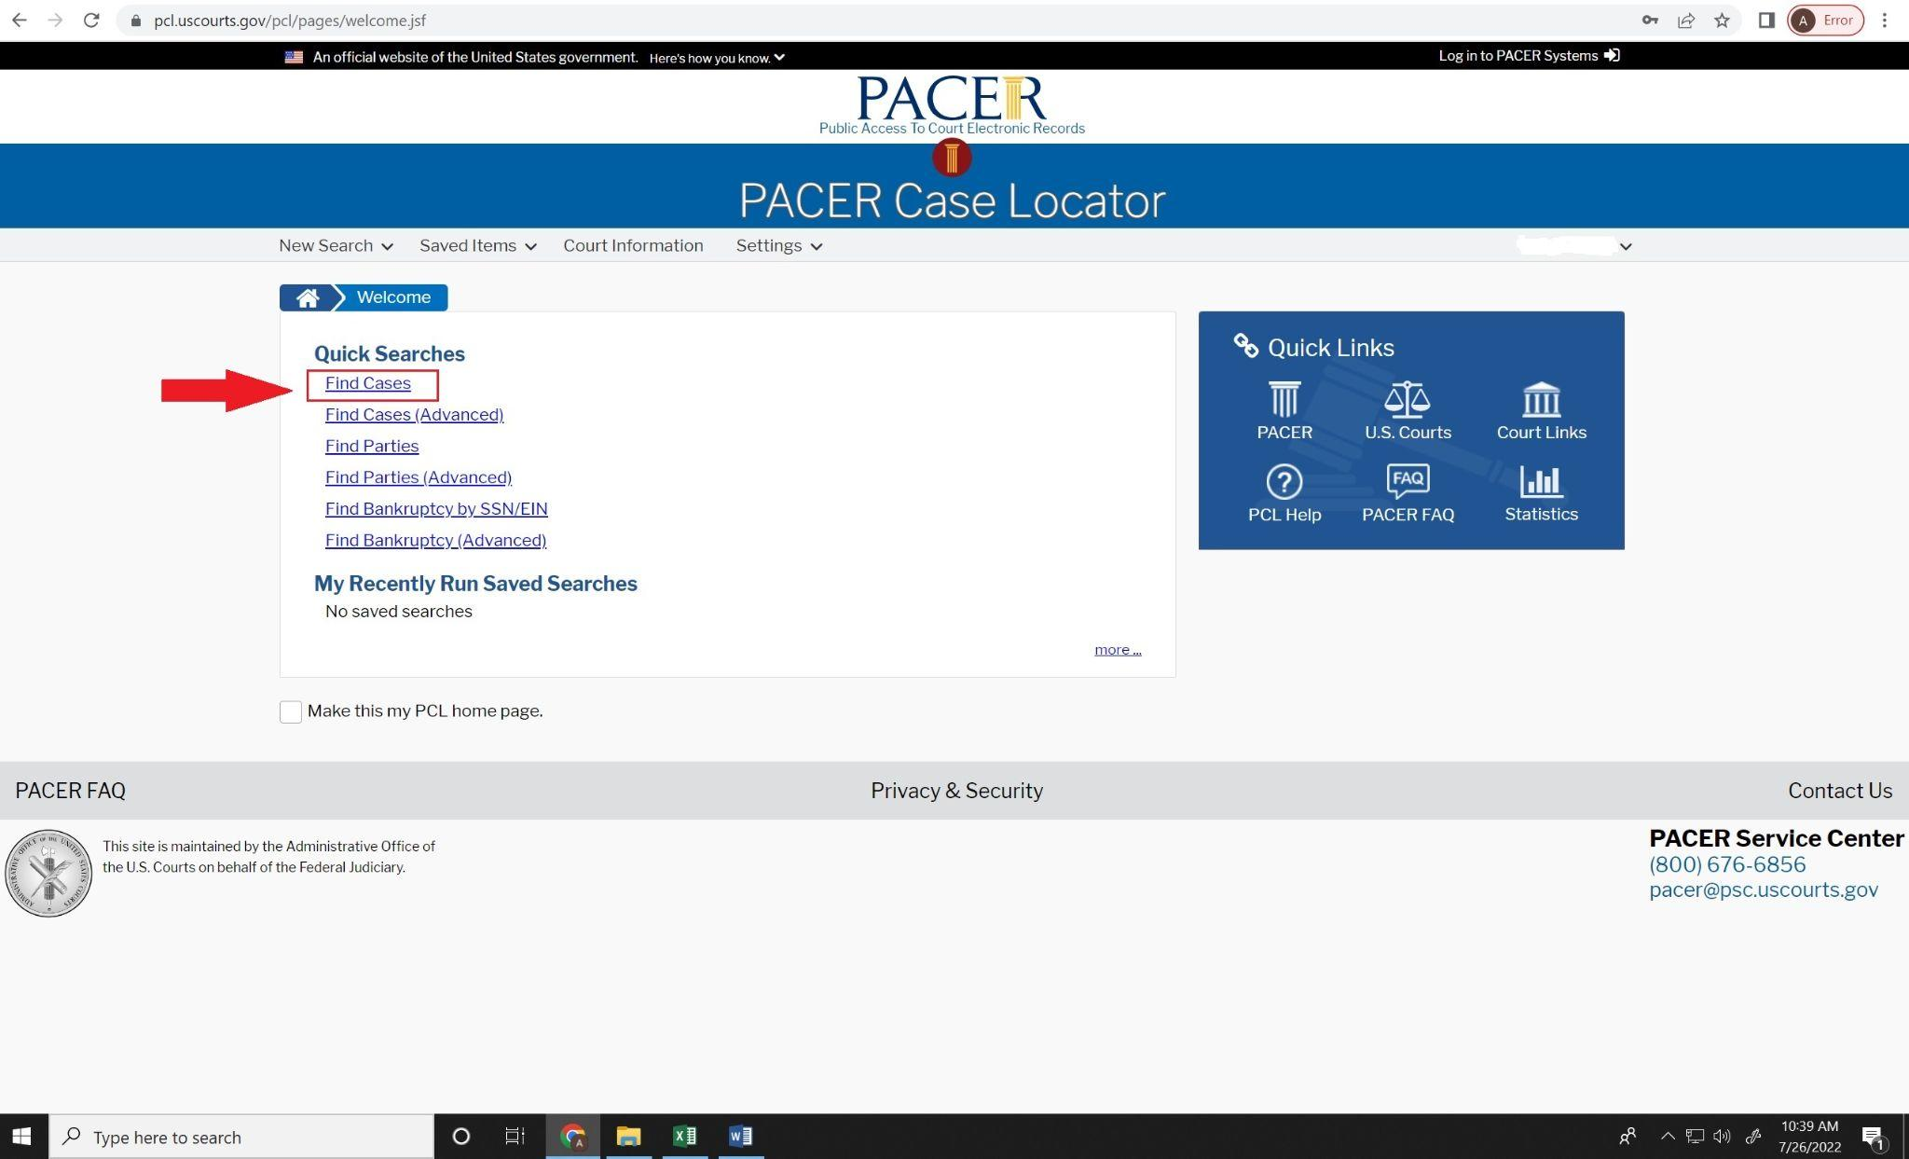

- Choose and click Find Cases

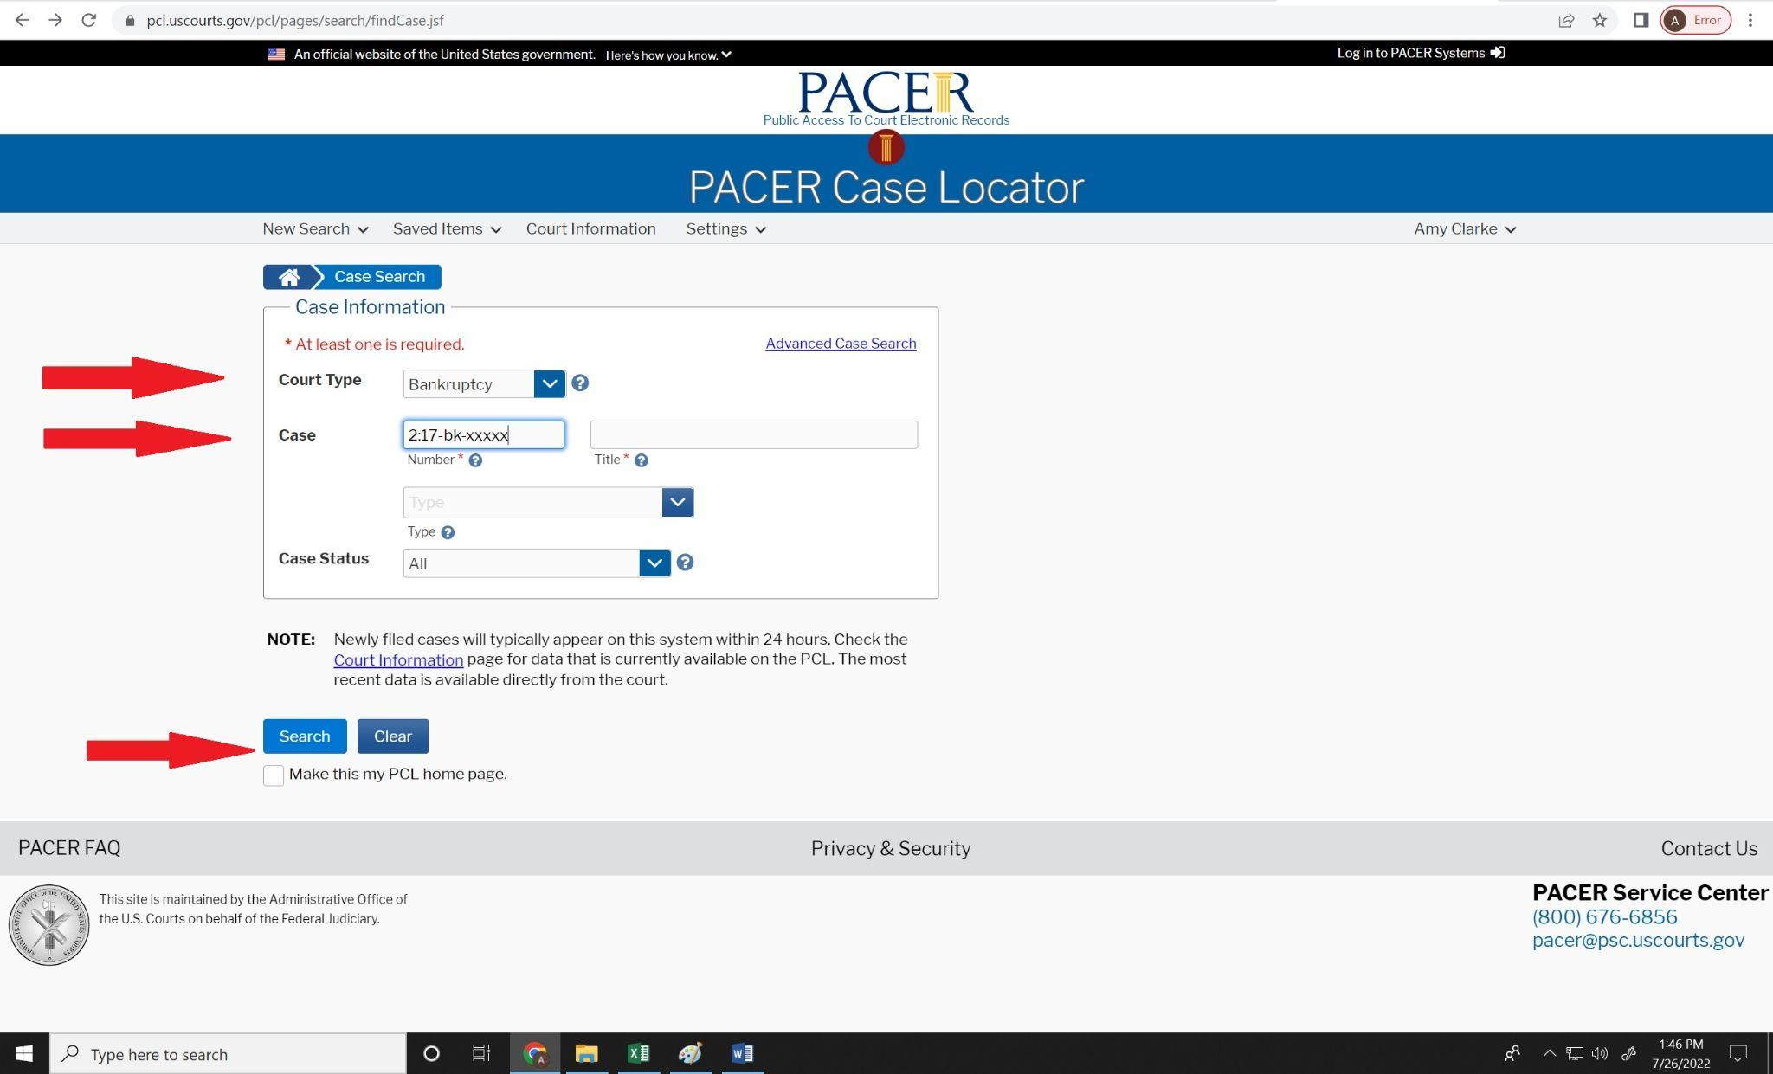
- Choose Bankruptcy in the dropdown.
- Enter the Bankruptcy case number.
The PACER system allows the entry of a case number in a variety of ways. Below are two simple and easy to remember formats:
1st recommended format 2:2017bkxxxxx
2nd recommended format 2:17-bk-xxxxx

- After entering the case number, proceed by clicking on the Search box. This command will pull up a list of all bankruptcy cases filed in the United States (including Hawaii, Alaska and US 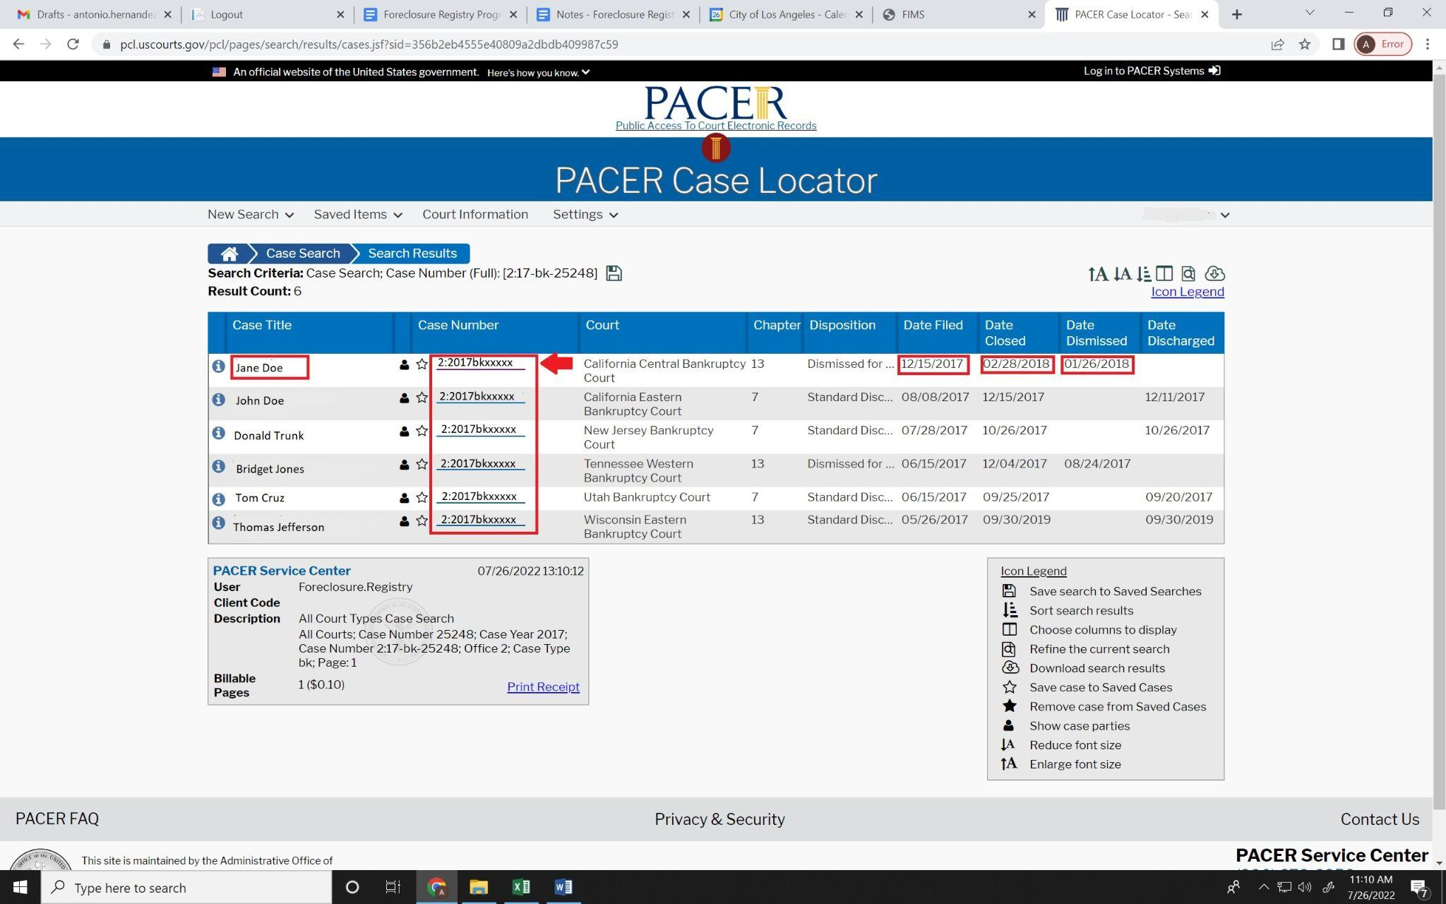territories) with the same number series for that particular year.
- Since we are concerned with the bankruptcy petition filed by Jane Doe, please click on the Case number link for Jane Doe which will direct us to the query page. 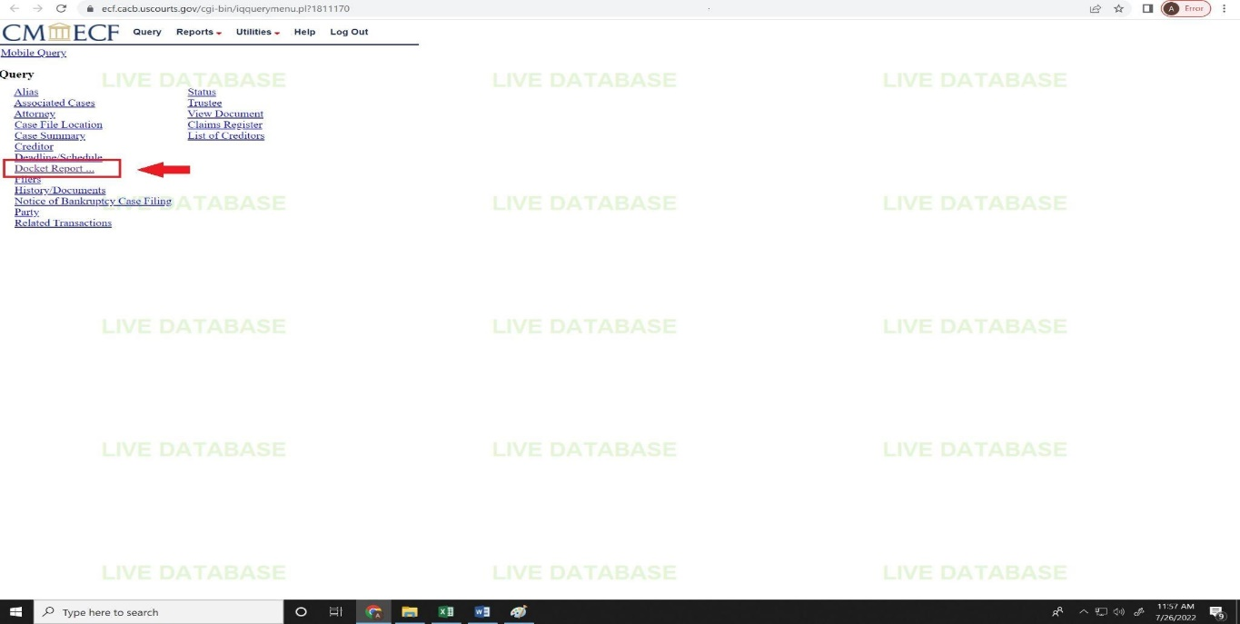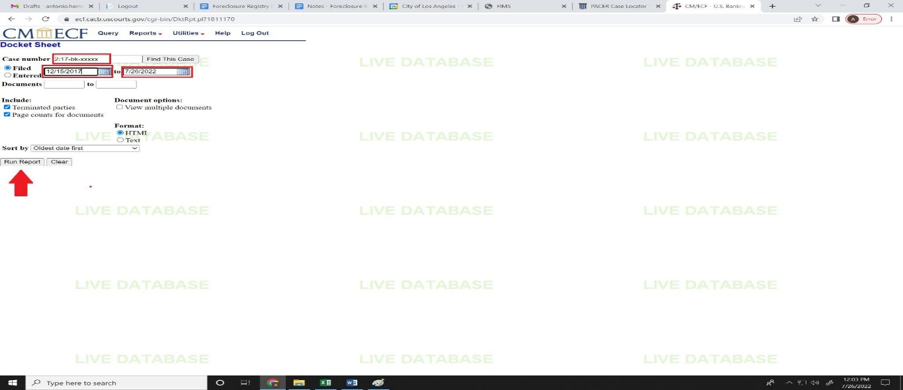
- Since our requirement is docket report, please click Docket Report in the query options. This will direct to a page where one is asked to enter preferred date range for our docket report.
The Start Date must be the Bankruptcy FILING DATE.The End Date must be either:
- Today’s Current Date, if evaluating a property for current registration exemption OR
- Penalty End Date on the Invoice, if we are evaluating an older foreclosure/invoice (that is no longer accruing) for potential partial or full penalty exemption

8. After entering correct Start and End Dates, proceed by clicking on the Run Report button.

This will pull up the docket report, a chronological account of motions, court judgments, proceedings and other information pertinent to the interest of all stakeholders impacted by the bankruptcy petition.

Below is the sample Docket Report for Jane Doe.
